|  |  |  |  |  |  |  |  |  |  |  |
| --- | --- | --- | --- | --- | --- | --- | --- | --- | --- | --- |
| **NFC Institute of Engineering & Fertilizer Research Faisalabad**  **Department of Mechanical Engineering** | | | | | | | | | | |
| **Course Name: Finite Element Analysis** | | | | | | | | | | |
| **Examination** | | **Course Code** | **Session** | **Semester** | | **Total Marks** | | **Maximum Time** | | |
| **CEP** | | **ME-451** | **2018** | **7th** | | **20** | | **1 week** | | |
| **Q. #** | **Statement** | | | **CLO** | **PLO** | | **Bloom Taxonomy** | | **Marks** | **KPI** |
| **Q. 1** | | | | **2** | **5** | | **C5** | | **10** | **50%** |
| **Evaluate the solution by using MATLAB code for given problem. Evaluate nodal dispacements, elemental forces and reaction forces** | | | | | | | | | | |

A rigid plane frame is defined here as a series of beam elements rigidly connected to each other; that is, the original angles made between elements at their joints remain unchanged after the deformation due to applied loads or applied displacements.

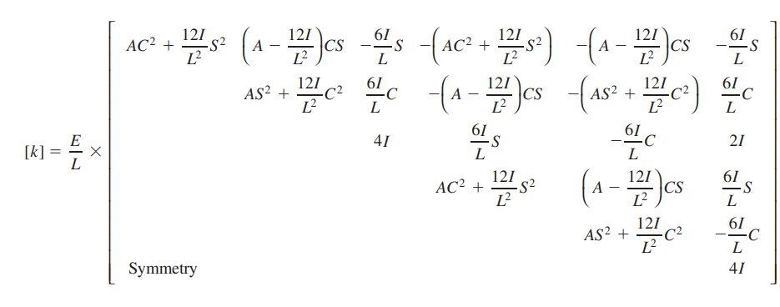K matrix for rigid plane frame

T matrix for Rigid plane frame

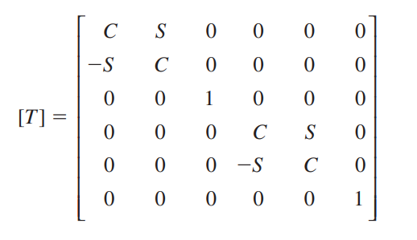

## Values Saved by MATLAB Workspace

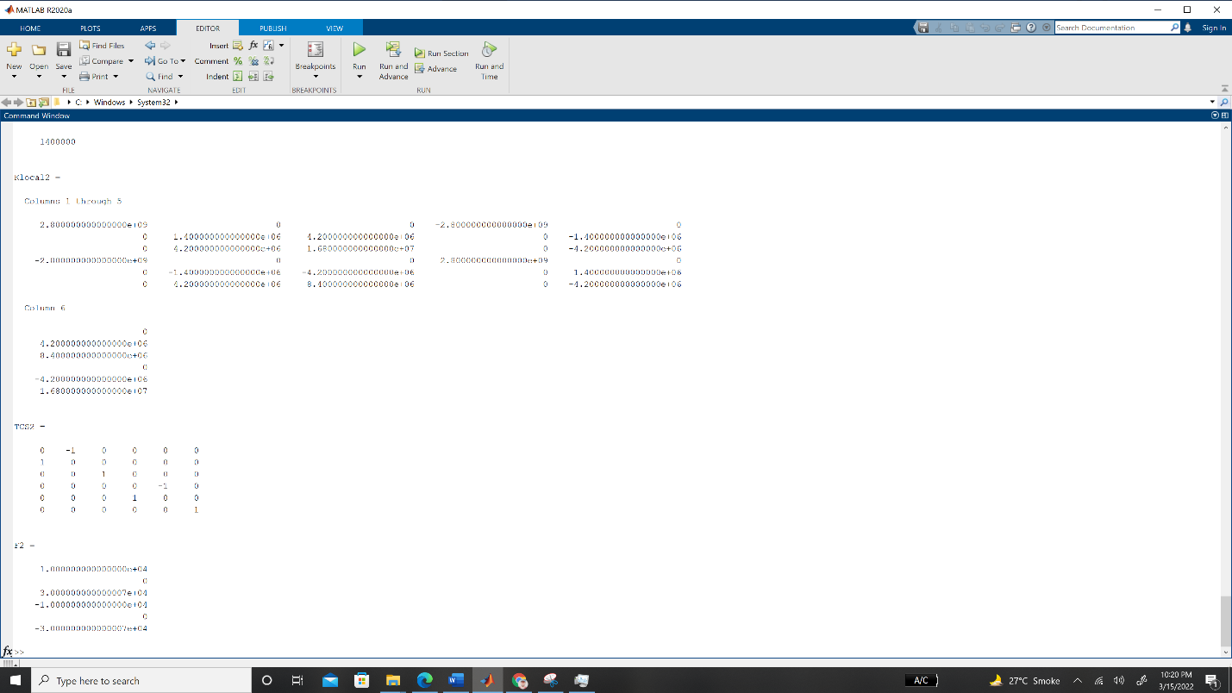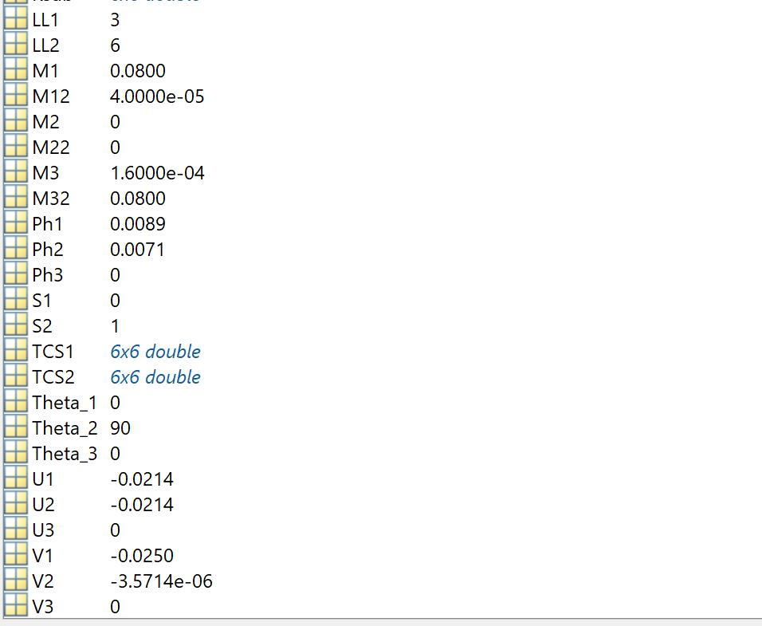

## Solution in Command Window

**M1 =**

8.000000000000000e-02

**M2 =**

0

**M3 =**

1.600000000000000e-04

**ISL =**

0

**ICL =**

2.400000000000000e-04

**K1 =**

**Columns 1 through 5**

5.600000000000000e+09 0 0 -5.600000000000000e+09 0

0 1.120000000000000e+07 1.680000000000000e+07 0 -1.120000000000000e+07

0 1.680000000000000e+07 3.360000000000000e+07 0 -1.680000000000000e+07

-5.600000000000000e+09 0 0 5.600000000000000e+09 0

0 -1.120000000000000e+07 -1.680000000000000e+07 0 1.120000000000000e+07

0 1.680000000000000e+07 1.680000000000000e+07 0 -1.680000000000000e+07

**Column 6**

0

1.680000000000000e+07

1.680000000000000e+07

0

-1.680000000000000e+07

3.360000000000000e+07

**K1a =**

**Columns 1 through 5**

5.600000000000000e+09 0 0 -5.600000000000000e+09 0

0 1.120000000000000e+07 1.680000000000000e+07 0 -1.120000000000000e+07

0 1.680000000000000e+07 3.360000000000000e+07 0 -1.680000000000000e+07

-5.600000000000000e+09 0 0 5.600000000000000e+09 0

0 -1.120000000000000e+07 -1.680000000000000e+07 0 1.120000000000000e+07

0 1.680000000000000e+07 1.680000000000000e+07 0 -1.680000000000000e+07

**Column 6**

0

1.680000000000000e+07

1.680000000000000e+07

0

-1.680000000000000e+07

3.360000000000000e+07

**K1a =**

**Columns 1 through 5**

5.600000000000000e+09 0 0 -5.600000000000000e+09 0

0 1.120000000000000e+07 1.680000000000000e+07 0 -1.120000000000000e+07

0 1.680000000000000e+07 3.360000000000000e+07 0 -1.680000000000000e+07

-5.600000000000000e+09 0 0 5.600000000000000e+09 0

0 -1.120000000000000e+07 -1.680000000000000e+07 0 1.120000000000000e+07

0 1.680000000000000e+07 1.680000000000000e+07 0 -1.680000000000000e+07

0 0 0 0 0

0 0 0 0 0

0 0 0 0 0

**Columns 6 through 9**

0 0 0 0

1.680000000000000e+07 0 0 0

1.680000000000000e+07 0 0 0

0 0 0 0

-1.680000000000000e+07 0 0 0

3.360000000000000e+07 0 0 0

0 0 0 0

0 0 0 0

0 0 0 0

**M12 =**

4.000000000000000e-05

**M22 =**

0

**M32 =**

8.000000000000000e-02

**ISL2 =**

1.200000000000000e-04

**ICL2 =**

0

**K2 =**

**Columns 1 through 5**

1.400000000000000e+06 0 4.200000000000000e+06 -1.400000000000000e+06 0

0 2.800000000000000e+09 0 0 -2.800000000000000e+09

4.200000000000000e+06 0 1.680000000000000e+07 -4.200000000000000e+06 0

-1.400000000000000e+06 0 -4.200000000000000e+06 1.400000000000000e+06 0

0 -2.800000000000000e+09 0 0 2.800000000000000e+09

4.200000000000000e+06 0 8.400000000000000e+06 -4.200000000000000e+06 0

**Column 6**

4.200000000000000e+06

0

8.400000000000000e+06

-4.200000000000000e+06

0

1.680000000000000e+07

**K2a =**

0 0 0 0 0 0 0 0 0

0 0 0 0 0 0 0 0 0

0 0 0 0 0 0 0 0 0

0 0 0 0 0 0 0 0 0

0 0 0 0 0 0 0 0 0

0 0 0 0 0 0 0 0 0

0 0 0 0 0 0 0 0 0

0 0 0 0 0 0 0 0 0

0 0 0 0 0 0 0 0 0

**K2a =**

**Columns 1 through 5**

0 0 0 0 0

0 0 0 0 0

0 0 0 0 0

0 0 0 1.400000000000000e+06 0

0 0 0 0 2.800000000000000e+09

0 0 0 4.200000000000000e+06 0

0 0 0 -1.400000000000000e+06 0

0 0 0 0 -2.800000000000000e+09

0 0 0 4.200000000000000e+06 0

**Columns 6 through 9**

0 0 0 0

0 0 0 0

0 0 0 0

4.200000000000000e+06 -1.400000000000000e+06 0 4.200000000000000e+06

0 0 -2.800000000000000e+09 0

1.680000000000000e+07 -4.200000000000000e+06 0 8.400000000000000e+06

-4.200000000000000e+06 1.400000000000000e+06 0 -4.200000000000000e+06

0 0 2.800000000000000e+09 0

8.400000000000000e+06 -4.200000000000000e+06 0 1.680000000000000e+07

**K =**

**Columns 1 through 5**

5.600000000000000e+09 0 0 -5.600000000000000e+09 0

0 1.120000000000000e+07 1.680000000000000e+07 0 -1.120000000000000e+07

0 1.680000000000000e+07 3.360000000000000e+07 0 -1.680000000000000e+07

-5.600000000000000e+09 0 0 5.601400000000000e+09 0

0 -1.120000000000000e+07 -1.680000000000000e+07 0 2.811200000000000e+09

0 1.680000000000000e+07 1.680000000000000e+07 4.200000000000000e+06 -1.680000000000000e+07

0 0 0 -1.400000000000000e+06 0

0 0 0 0 -2.800000000000000e+09

0 0 0 4.200000000000000e+06 0

**Columns 6 through 9**

0 0 0 0

1.680000000000000e+07 0 0 0

1.680000000000000e+07 0 0 0

4.200000000000000e+06 -1.400000000000000e+06 0 4.200000000000000e+06

-1.680000000000000e+07 0 -2.800000000000000e+09 0

5.040000000000000e+07 -4.200000000000000e+06 0 8.400000000000000e+06

-4.200000000000000e+06 1.400000000000000e+06 0 -4.200000000000000e+06

0 0 2.800000000000000e+09 0

8.400000000000000e+06 -4.200000000000000e+06 0 1.680000000000000e+07

**Ksub =**

**Columns 1 through 5**

5.600000000000000e+09 0 0 -5.600000000000000e+09 0

0 1.120000000000000e+07 1.680000000000000e+07 0 -1.120000000000000e+07

0 1.680000000000000e+07 3.360000000000000e+07 0 -1.680000000000000e+07

-5.600000000000000e+09 0 0 5.601400000000000e+09 0

0 -1.120000000000000e+07 -1.680000000000000e+07 0 2.811200000000000e+09

0 1.680000000000000e+07 1.680000000000000e+07 4.200000000000000e+06 -1.680000000000000e+07

**Column 6**

0

1.680000000000000e+07

1.680000000000000e+07

4.200000000000000e+06

-1.680000000000000e+07

5.040000000000000e+07

**Fy =**

-10000

**Fpart =**

0

-10000

0

0

0

0

**D =**

**-**2.142857142857148e-02

-2.500357142857148e-02

8.928571428571449e-03

-2.142857142857148e-02

-3.571428571428571e-06

7.142857142857159e-03

**U1 =**

-2.142857142857148e-02

**V1 =**

-2.500357142857148e-02

**Ph1 =**

8.928571428571449e-03

**U2 =**

-2.142857142857148e-02

**V2 =**

-3.571428571428571e-06

**Ph2 =**

7.142857142857159e-03

**U3 =**

0

**V3 =**

0

**Ph3 =**

0

**D1 =**

-2.142857142857148e-02

-2.500357142857148e-02

8.928571428571449e-03

-2.142857142857148e-02

-3.571428571428571e-06

7.142857142857159e-03

0

0

0

**FM =**

0

-9.999999999999956e+03

4.365574568510056e-11

6.912159733474255e-11

-4.365574568510056e-11

0

0

1.000000000000000e+04

-3.000000000000007e+04

**AEL =**

5.600000000000000e+09

**EIL =**

**16800000**

**EIL1 =**

33600000

**EIL2 =**

16800000

**EIL3 =**

11200000

**Klocal1 =**

**Columns 1 through 5**

5.600000000000000e+09 0 0 -5.600000000000000e+09 0

0 1.120000000000000e+07 1.680000000000000e+07 0 -1.120000000000000e+07

0 1.680000000000000e+07 3.360000000000000e+07 0 -1.680000000000000e+07

-5.600000000000000e+09 0 0 5.600000000000000e+09 0

0 -1.120000000000000e+07 -1.680000000000000e+07 0 1.120000000000000e+07

0 1.680000000000000e+07 1.680000000000000e+07 0 -1.680000000000000e+07

Column 6

0

1.680000000000000e+07

1.680000000000000e+07

0

-1.680000000000000e+07

3.360000000000000e+07

**TCS1 =**

1 0 0 0 0 0

0 1 0 0 0 0

0 0 1 0 0 0

0 0 0 1 0 0

0 0 0 0 1 0

0 0 0 0 0 1

**F1 =**

0

-9.999999999999956e+03

4.365574568510056e-11

0

9.999999999999956e+03

-3.000000000000003e+04

**AEL2 =**

2.800000000000000e+09

**EIL2 =**

8400000

**EIL12 =**

16800000

**EIL22 =**

4200000

**EIL32 =**

1400000

**Klocal2 =**

**Columns 1 through 5**

2.800000000000000e+09 0 0 -2.800000000000000e+09 0

0 1.400000000000000e+06 4.200000000000000e+06 0 -1.400000000000000e+06

0 4.200000000000000e+06 1.680000000000000e+07 0 -4.200000000000000e+06

-2.800000000000000e+09 0 0 2.800000000000000e+09 0

0 -1.400000000000000e+06 -4.200000000000000e+06 0 1.400000000000000e+06

0 4.200000000000000e+06 8.400000000000000e+06 0 -4.200000000000000e+06

**Column 6**

0

4.200000000000000e+06

8.400000000000000e+06

0

-4.200000000000000e+06

1.680000000000000e+07

**TCS2 =**

0 -1 0 0 0 0

1 0 0 0 0 0

0 0 1 0 0 0

0 0 0 0 -1 0

0 0 0 1 0 0

0 0 0 0 0 1

**F2 =**

1.000000000000000e+04

0

3.000000000000007e+04

-1.000000000000000e+04

0

-3.000000000000007e+04